Shiploader Questionnaire
Customer Information:

Name & Title: |  |  |  |  |  |  |  |  | Phone
Address |  |  |  |  |  |  |  |  | Fax
Address (cont.) |  |  |  |  |  |  |  |  | E-mail
City |  |  |  |  |  |  |  |  | Mobile:
ZIP Code |  |  |  |  |  |  |  |  | Other Phones:
Country
Project’s General Information:

Customer's reference |  |  |  |  |  |  |  |  | Type of project: |  |  |  |  |  |  | budgetary
End user name |  |  |  |  |  |  |  |  |  |  |  |  |  |  |  | ffirm
Location: |  |  |  |  |  |  |  |  | Please State Delivery Conditions (CIF, FOB, Turn Key,etc.)
Country:
Time Frame and Project’s Schedule:

Tender deadline |  |  |  |  |  |  |  |  | Delivery:
Estimated Purchasing date: |  |  |  |  |  |  |  |  | Start-up and Commissioning:
Comments
Applicable Standards:

General power supply: |  |  |  |  |  | V |  |  |  |  |  | Hz
Required Standards:
Service: |  |  |  |  |  | h/day |  |  |  |  | d/year
Specification of the Material to be Loaded and Site Conditions:

Material Specifications: |  |  |  |  | 1 |  |  | 2 |  |  |  |  |  |  |  | 3
Material
Angle of repose
Moisture (%)
Sticky material (yes/no)
Hygroscopic material (yes/no)
Density (t/m³)
Grain size (mm)
Max. lump size (mm)
Nominal loading rate (t/h)
Peak , if any
Year throughput (t/year)
Dedusting requested (yes/no)
Material Additional Information:
Site conditions:
Max. relative humidity: |  |  |  |  |  |  |  |  | Min. relative humidity:
Max. temperature: |  |  |  |  |  |  |  |  | Min. temperature:
Rainfall average per year: |  |  |  |  |  |  |  |  | Max. rainfall per hour:
(*) Maximum wind velocity in operation (m/sec): |  |  |  |  |  | m/sec |  |  | Altitude above sea level:
(*) Maximum wind velocity out of service (m/sec): |  |  |  |  |  | m/sec
(*) Only Outdoor Installations
Equipment Requirements:

Shiploader Arrangement
Fixed Arrangement |  |  |  |  | Travelling
Rail track:
Required: |  |  |  |  | Yes  No |  |  |  | If existing rail track, specify existing rail section:
Maximum Traveling length: |  |  |  |  |  |  |  |  | Maximum admissible wheel pressure:
Shiploader Feeding Conveying System:
Required: |  |  |  |  | Yes  No
Total Length: |  |  |  |  |  |  |  |  | Belt Width:
Other Equipment:
If you want to include a sketch of your Terminal and e-mail it to sales@InTechnikusa.com
Shiploader Design Dimensions:
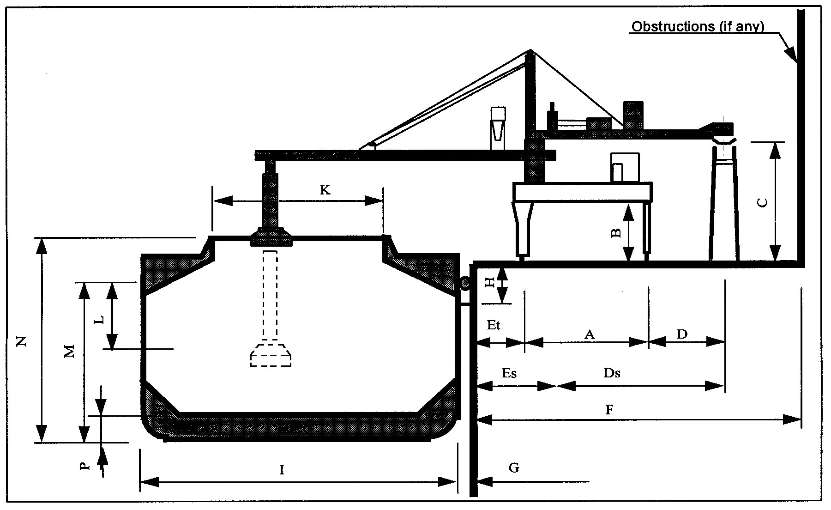 |  |  |  |  |  |  |  |  | About the Pier Dimensions:
 |  |  |  |  |  |  |  |  | A = Rail Span
 |  |  |  |  |  |  |  |  | B = Shiploader Clearance
 |  |  |  |  |  |  |  |  | C = Feed Conveyor Height
 |  |  |  |  |  |  |  |  | D = Distance from landside rail to Feed Conveyor
 |  |  |  |  |  |  |  |  | E = Distance from pier edge to sea land rail
 |  |  |  |  |  |  |  |  | F = Distance from pier edge to Buildings or warehouses
 |  |  |  |  |  |  |  |  | G = Fender Height
 |  |  |  |  |  |  |  |  | H = Distance from water sea level to pier edge
Comments: |  |  |  |  |  |  |  |  | About the Ships to be loaded:
 |  |  |  |  |  |  |  |  | Maximum Vessel DWT:
 |  |  |  |  |  |  |  |  | Minimum Vessel DWT;
 |  |  |  |  |  |  |  |  | I = Ship Beam
 |  |  |  |  |  |  |  |  | K = Hatch Width
 |  |  |  |  |  |  |  |  | L = Freeboard – Ship Empty
 |  |  |  |  |  |  |  |  | M = Freeboard – Ship Fully Loaded
 |  |  |  |  |  |  |  |  | N = Ship Height (from keel to top of cargo hatch:
 |  |  |  |  |  |  |  |  | O = Ship Total Length
 |  |  |  |  |  |  |  |  | P = Double bottom height
Name: |  |  |  |  |  |  |  |  |  | Date:
Please e-mail this form to sales@InTechnikusa.com, or print out and fax it to InTechnik, Attn.: Technical Department Fax: + 1 972 618 1471

